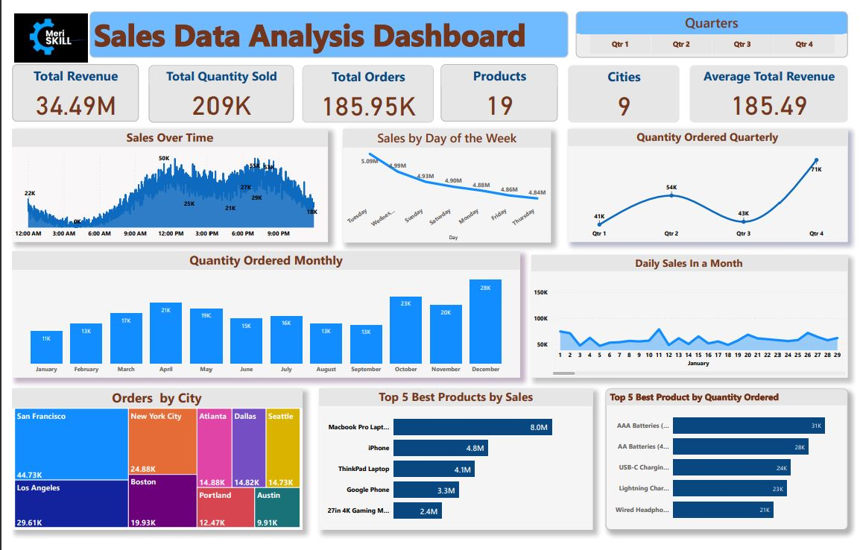

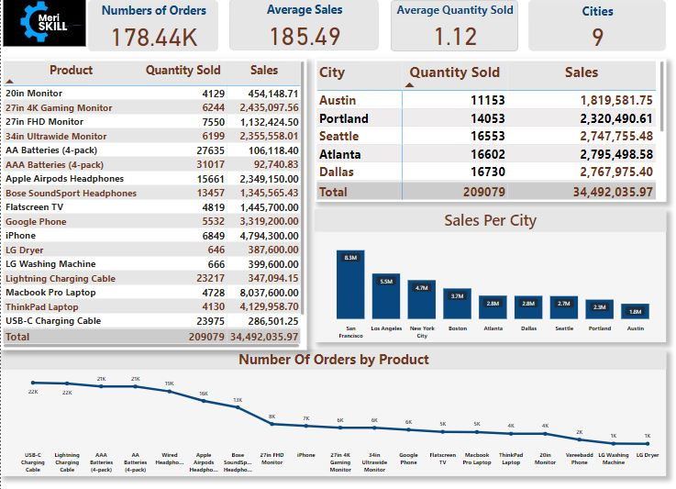

**Key insights**  
**SALES TRENDS ACROSS TIME:**

The highest sales are always recorded about 12pm and around 6pm-9pm. With Tuesdays and Wednesdays are the pick sales days within a week respectively. December is the month with the highest amount sales within a calendar year and the fourth Quarters shows strong trends of highest sales and revenue made against other quarters in the year.

**City Sales Reports**: San Francisco recorded the highest amount of revenue with 8.3M generated in sales and over 447300 orders were made in this particular city.

**Product Sold**: A total of 209k products were sold generating about 34.4M in revenue. With Top products like Macbook pro laptop, iphones and Thinkpads Laptops leading in sales and AAA Batteries (4 packs) and AA batteries 4 packs being the best ordered products. Most products were sold in December making it the best month in which more quantity of the products were ordered.

**RECOMMENDATIONS**  
1.more investment should be made in products like Macbook pro and iPhones as they portrayed consistency in generating more revenue.  
2. Expansion in operations and marketing should be made to cities like San Francsciso ,Los Angeles and New York for increased as they showcases ability to generating more revenue.  
3. Effective sales strategy should be executed especially in most cities to increase sales especially in the last quarters of the year.  
4. Since 12pm-6pm represent peak sales hours, there should be a"happy hour" bonanza for customers with the highest quantity ordered